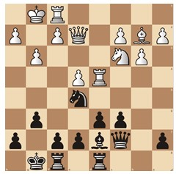    
Chessable call for decision-making test participants

How well do chess players with different ratings solve different types of tactical chess positions?
And how long does it take them to do so?
The Chessable science team invites chess players to take part in an online test.
This test is part of research on decision making in chess.
The test consists of ten positions which should be solved in a maximum of five minutes each. Before the test begins, there are two sample puzzles. After solving the positions, participants may answer some questions via a link.
Chess players of all levels can participate. The only condition is to have a FIDE Elo rating.
To participate, click on https://chessable.typeform.com/decisionmaking to fill in a short questionnaire (Elo rating, name, etc.). After a few weeks you will get a link to the online test.
The questionnaire closes on October 15, 2023.
Names of participants will be kept confidential. The research results will lead to a paper and a blog on the Chessable site.
Via the questionnaire participants can opt for a one-month free Chessable PRO Account. To get the Chessable PRO account, list your existing Chessable account or create a Chessable account for free at www.chessable.com. After November 21 you will see the PRO status when you open your account.

Links and contact information
Chessable PRO Account: https://www.chessable.com/pro
Chessable science: https://www.chessable.com/science and click on the green banner “View Our Active Scientific Research”
Chessable science blogs:
https://www.chessable.com/blog/chess-science
https://www.chessable.com/blog/fall-2023-chessable-research-awards-winners
For questions or remarks, please contact Karel van Delft
Chessable science project manager
karel.vandelft@chess.com

